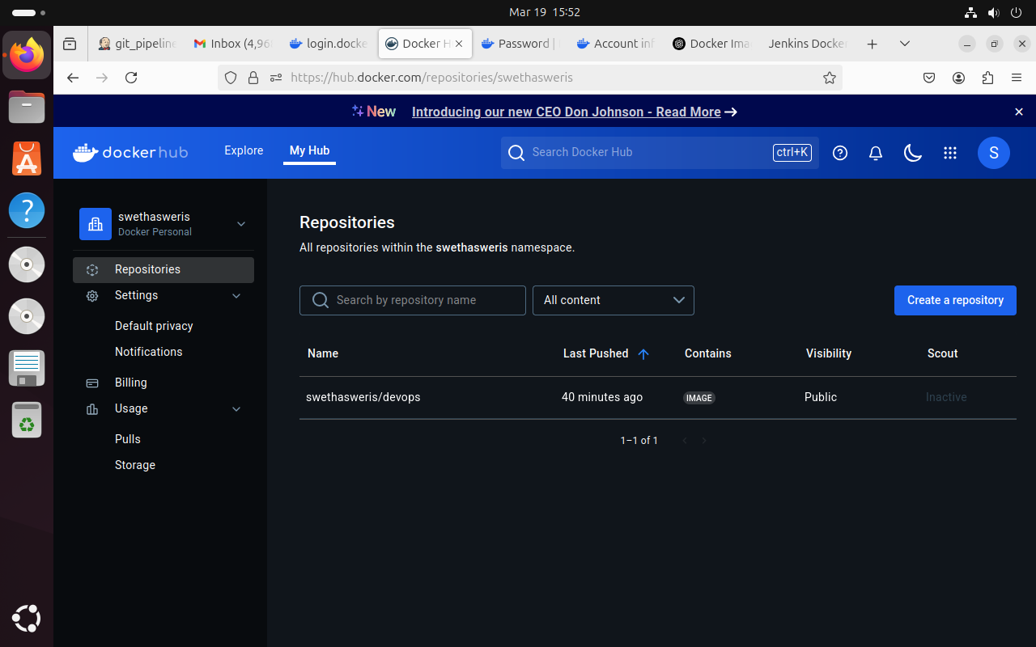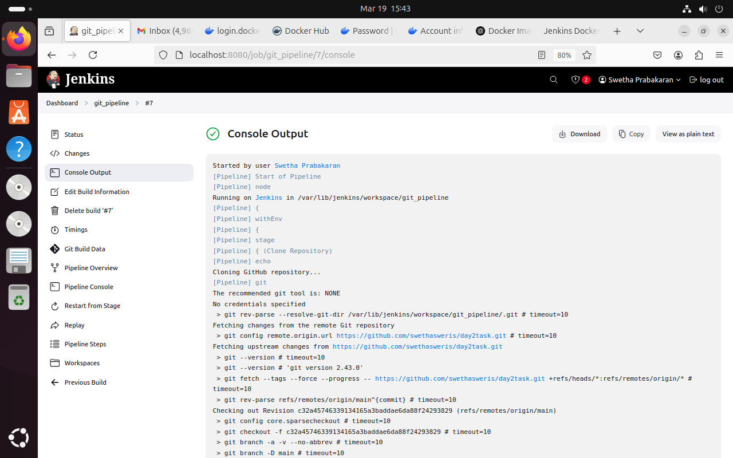

Final console output you ge after successfully building through pipeline

Creating a repository in docker

Script code

pipeline {  
    agent any  
  
    environment {  
        IMAGE\_NAME = "swethasweris/devops" // Replace with your Docker Hub username and image name  
        TAG = "latest"  
        CONTAINER\_NAME = "my-container"  
        PORT = "3001"  
    }  
  
    stages {  
         
        stage('Clone Repository') {  
            steps {  
                echo "Cloning GitHub repository..."  
                git '[https://github.com/swethasweris/day2task.git](https://github.com/swethasweris/day2task.git" \t "https://mail.google.com/mail/u/0/?tab=rm&ogbl" \l "inbox/_blank)' // Replace with your repo URL  
            }  
        }  
  
        stage('Build Docker Image') {  
            steps {  
                echo "Building Docker image..."  
                sh 'chmod +x build.sh'  
                sh './build.sh'  
            }  
        }  
  
                stage('Login to Docker Hub') {  
            steps {  
                echo "Logging into Docker Hub..."  
                withCredentials([usernamePassword(credentialsId: 'docker-hub-creds', usernameVariable: 'DOCKER\_USER', passwordVariable: 'DOCKER\_PASS')]) {  
                    sh 'docker login -u $DOCKER\_USER -p $DOCKER\_PASS'  
                }  
            }  
        }  
  
        stage('Push Docker Image') {  
            steps {  
                echo "Pushing Docker image to Docker Hub..."  
                sh "docker tag $IMAGE\_NAME:$TAG $IMAGE\_NAME:$TAG"  
                sh "docker push $IMAGE\_NAME:$TAG"  
            }  
        }  
  
        stage('Deploy Docker Container') {  
            steps {  
                echo "Deploying Docker container..."  
                sh 'chmod +x deploy.sh'  
                sh './deploy.sh'  
            }  
        }  
    }  
  
    post {  
        success {  
            echo "Deployment Successful!"  
        }  
        failure {  
            echo "Deployment Failed!"  
        }  
    }  
}

|  |
| --- |
|  |

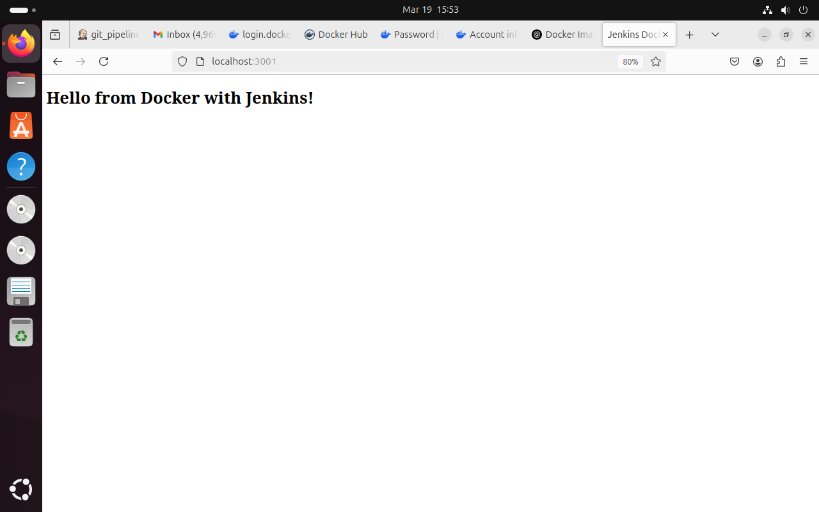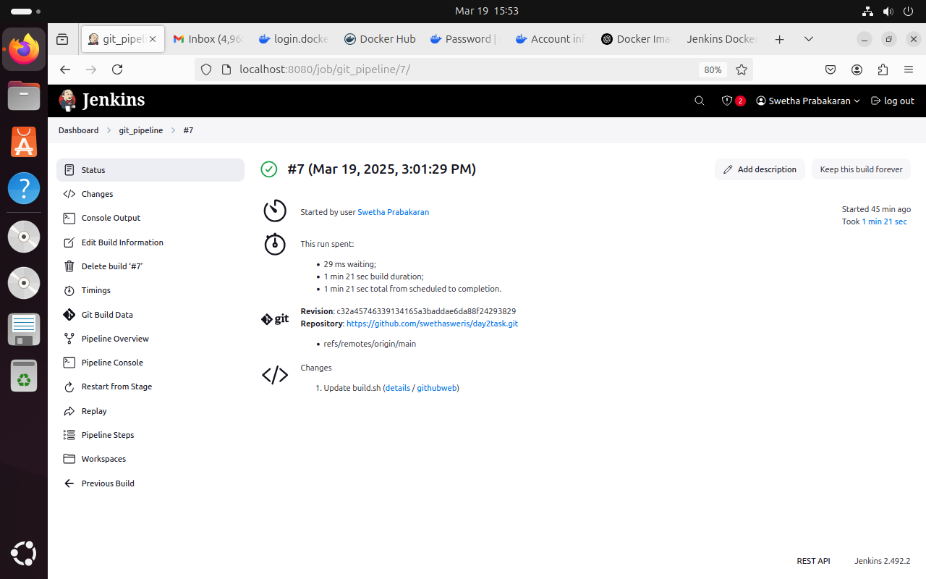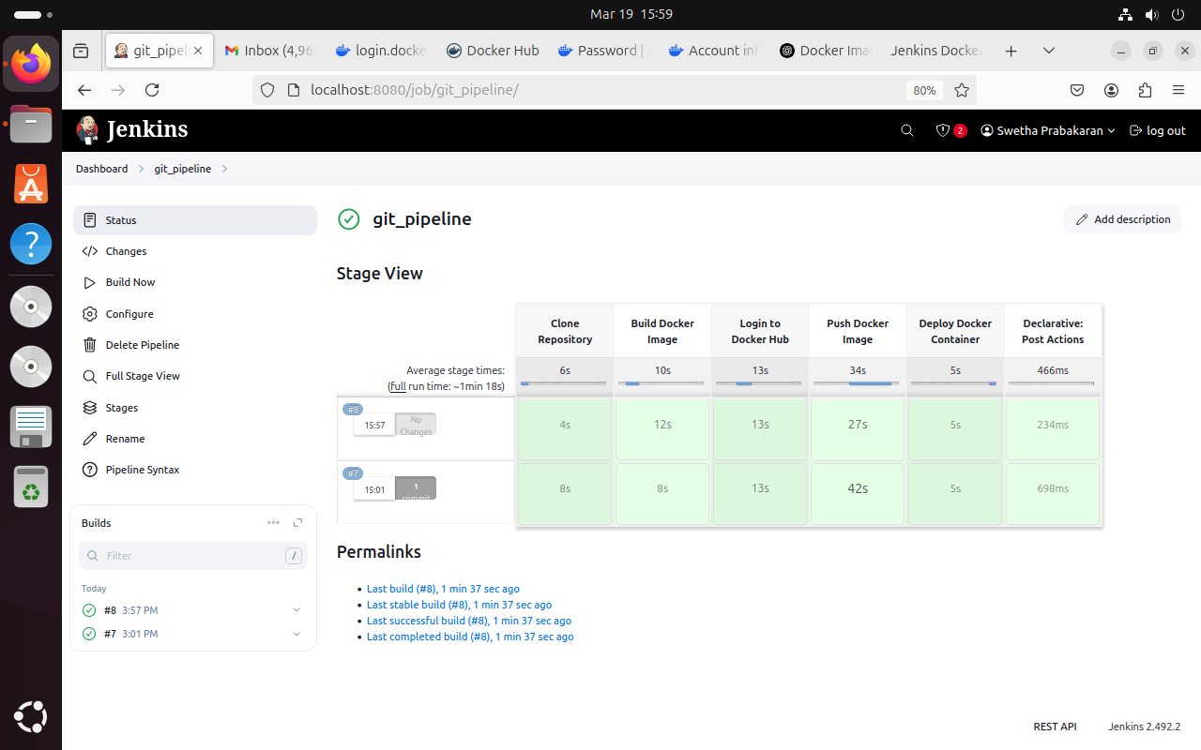

When you put localhost:3001 , after executing jenkins you will be taken to the url page